Today’s kids have remarkably different childhoods than previous generations.

Naturally, just like Baby Boomers or other generations of the past, youngsters in the 21st century are raised by helpful parents and family members, while also becoming subject to the influences from  complex socio-economic and cultural factors of their time.

But children today are experiencing an influence that has had a nearly quantum impact on social and cognitive development as well as learning styles.

Yes, you’ve guessed it: technology.

Born in the age of internet and hyper connectivity, today’s kids are digital natives with an ability to pick up and master new technologies with a speed and fluency that boggles the mind.

While some of this is frightening to parents, it is also imperative that we all come to grips with the fact that technology is not going away, and that there are many positive sides to it as well.

One can also argue that in order to get a leg up in tomorrow’s world, it will be very important to understand the language of technology, and that there is no better way to do this than to learn how to code.

In addition to the obvious benefit of empowering kids with actionable knowledge they can use in the future, there are plenty of reasons why they should learn computer programming.

In this article, I will explore several important reasons why teaching computer programming is now mission critical  as well as give you some advice on how to help your kids get started.

Top Reasons Your Kids Should Learn Computer Programming

Enabling your kids to explore the world of coding can be incredibly rewarding for them. From cognitive development and precious skill building, to creative expression and smart investment in the future – there are a lot of well-argumented pros we can discuss.

Let’s just go through a few of the most important:

* Positive influence on cognitive development

The correlation between learning computer programming and cognitive development was first noted in the early eighties. Seymour Papert, MIT mathematician and one of the founders of programming language called LOGO, was among the first researchers interested in the subject of kids coding and cognitive development.

According to Papert, if children engage in high-quality computer programming education, they experience what is known as [“Piagetian learning” or “learning without being taught](https://www.researchgate.net/profile/Douglas_Clements/publication/232539181_Effects_of_Computer_Programming_on_Young_Children%27s_Cognition/links/0c96053626d4ec684a000000/Effects-of-Computer-Programming-on-Young-Childrens-Cognition.pdf).” He proposed that computer programming provides an environment in which abstract notions (previously too complex for kids to master) – become more concrete and tangible. Simultaneously, coding education teaches kids*how* to think, instead of *what* to think.

When kids face a coding problem, they quickly realize that breaking it into smaller pieces is the most effective way to solve it. This approach is called computational thinking and it’s great for tackling any other type of problem in the real world.

Although Papert’s findings were widely questioned at the time (mainly due to the insufficient size of the research sample), new studies conducted in recent decades showed that coding can indeed boost kids’ cognitive development, especially when it comes to metacognitive abilities, operational competence, self-assessment, and even divergent thinking.

* STEM occupations are the present and the future of the U.S. job market

Computer programming teaches kids skills that are instantly relevant on the job market, and due to the fact we live in the ever-evolving age of digital transformation – these skills can be employed in various industries.

According to the [report about STEM occupations issued by the U.S. Bureau of Labour Statistics](https://www.bls.gov/spotlight/2017/science-technology-engineering-and-mathematics-stem-occupations-past-present-and-future/pdf/science-technology-engineering-and-mathematics-stem-occupations-past-present-and-future.pdf), the future is blindingly bright for developers, programmers, software engineers, and computer scientists.

Employment in computer occupations is expected to grow by 12.5% between 2014 and 2024, which will result in more than half a million new jobs in the field. The economic side is also favorable: 93% of STEM occupations have wages above the national average. This means your kids will have amazing chances of excelling in their career, while also enjoying great financial stability.

* Coding is a Liberal Art

Writing code can be equally stimulating as learning French or playing guitar. The main touch point between coding and liberal arts is the development of critical and creative thinking skills. Instead of relying on memorizing formulas or definitions, kids who learn computer programming are challenged to come up with their own solutions the moment they master the syntax and unlock the way sequences work.

Having a computer programming curriculum that’s well-rounded and age-appropriate is crucial for two main reasons. First, kids will gradually adopt new knowledge that will be comprehensive and thorough, meaning they will have a solid ground for employing their own ideas and experimenting. Secondly, they will have the opportunity to maximize their potential and strengthen their critical thinking, which is going to be a handy skill in real life. If they truly commit to learn computer programming, they will have a chance to develop their own hypotheses and test them out in reality, seek solutions on their own and apply logic and reasoning, and enjoy coding as a fun activity that encourages them to make their own choices.

In addition to above mentioned, there is a psychological benefit of learning how to code that’s not that widely discussed. Namely, when kids learn the basics, they will try out different things in practice and familiarize themselves with failing. Developing  a healthy attitude towards failure and perceiving it as an important part of learning, means they will build confidence and persistence in the future.

Now that we’ve covered some of the main ways your kids can benefit from learning computer programming, let’s move on to the best ways to support them in getting started.

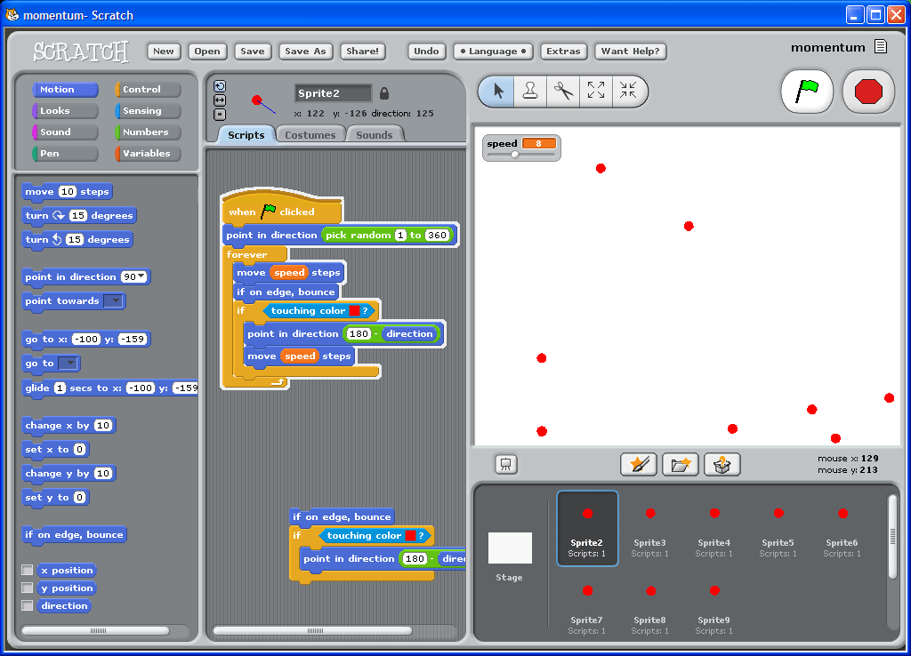

1. Start with Visual Block Coding, Then Move to Text

You remember how before learning how to ride a bicycle, you used training wheels or started off with riding a tricycle first? A similar teaching system is used when it comes to coding.

Before actually writing code, kids first need to understand how programs are made. That’s where visual programming comes in.

As seen in the above image, visual block programming is based on the drag-and-drop technique, where blocks are used to create executable code. It makes a natural first step, perfect for the youngest of students, that allows users to create even the most complex games with ease, simply by connecting the blocks. Programming components such as actions and events, are stacked together in a specific sequence, so kids can instantly see how their chosen disposition functions in reality.

In order to learn computer programming the right way, kids need to get a firm grip on the logic behind coding and understand what loops, methods, variables, and other vital concepts are, and visual interfaces enable them to do so. For example, Scratch uses specific shapes to mark loops: the blocks are shaped like sideways “U” letters, making it easy as pie for kids to recognize and memorize what repeat loops are. Blockly, which is more of a visual editor than an actual programming language, allows kids to see the code that drives each visual block via the side screen.

In our personal experience, it does not take long for kids to outgrow the visual programming languages and move on to typing the codes themselves.

## 2. Find Projects That are of Interest to Your Child

The best way to motivate your kids to learn computer programming is to support their curiosity and let them freely choose their main interests. Once they realize the “machinery behind the scenes” of today’s popular games and apps, they will understand the vast possibilities of coding in means of creating fun final products. This will trigger their creativity and inspire them to learn, because there is an undeniable application of their programming knowledge in the real world.

If your kids are interested in Minecraft coding, then learning Java makes the perfect choice. Here at CodaKid, we use helper files and the Eclipse text editor to bridge the gap between coding and creativity, and simplify the learning process. Kids can [learn how to create Minecraft mods](https://codakid.com/kids-online-coding-courses/mod-creation-adventure-begins/) with minimum strain, all thanks to the great curriculum and the experienced software developers, educators, and designers who are at students’ disposal. Java is great to start with specifically because its core concepts are shared by so many other programming languages.

In case your kid is passionate to specialize in [app development](https://codakid.com/kids-online-coding-courses/app-development-javascript/), we suggest starting with JavaScript, the number one language for 2D development, be it apps, games, or web pages. Python is another kid-friendly language that’s fairly easy to learn. In addition to powering up renown websites such as Spotify, Instagram, and YouTube – it is used for game development. If robotic kits are something your kid is into, we suggest those based on scripting languages like Arduino.

As you can see, there are plenty of choices. The moment your son or daughter masters the basics of computational thinking, he or she will find it easy to alter the main subject of their study in the future.

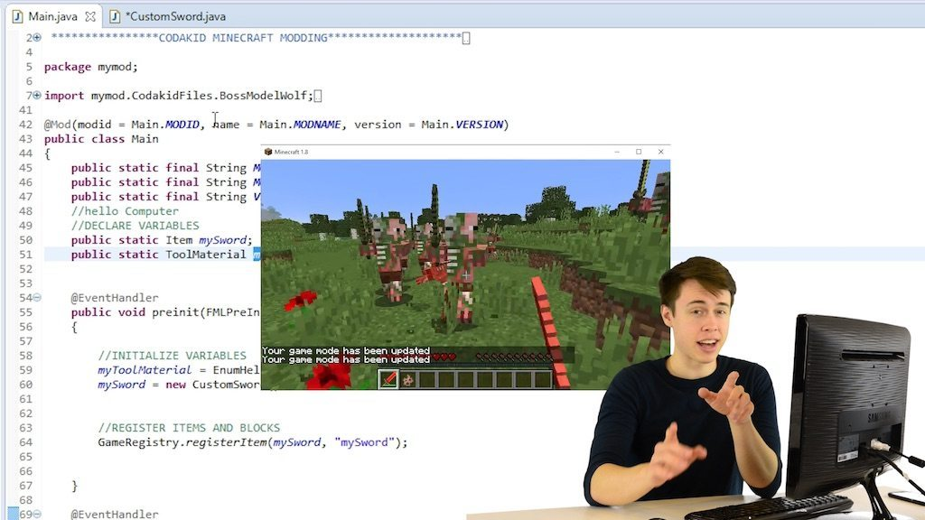

## 3. Seek out Online or Local Courses in Academies

As coding for kids continues to gain traction, a lot of new and amazing learning resources are emerging. Thanks to the internet, there is a plethora of possible online courses kids can try out. Physical books and guides are undoubtedly useful too, but the lack of interactivity may be off putting to your child or leave a wrong impression that coding is something dreadfully boring.

Choosing the right type of studying materials can make a difference between actually sparking your kids’ interest to learn and them deciding computer programming is not something worthy of their time.

[](https://codakid.com/kids-online-coding-courses/)

There are a number of high-quality local courses across the globe and some of them are even free such as CoderDojo, GirlsWhoCode, or Hour of Code events.

As for online courses, they can be focused on a single language (such as [Scratch](https://scratch.mit.edu/)), or they can cover more than just one field, such as the [Khan Academy](https://www.khanacademy.org/) which allows students to independently study JavaScript basics, HTML, CSS, etc. The Khan Academy currently does not provide student support nor does it have video tutorials for every study area that offers. [Code.org](https://code.org/) is another useful stop, used mainly by teachers in classrooms who are set out to introduce computer science to kids. Even though this resource incorporates the element of fun to learning, it is a bit limiting since kids never get to experience the feeling of building something on their own from scratch.

Lastly, we at CodaKid offer [online coding courses](https://codakid.com/kids-online-coding-courses/) for as little as $21 USD per month (when billed annually), in addition to camps, codeathons, and other types of face-to-face learning.



## 4. Find summer tech camps

Summer tech camps are an amazing way to mix fun, socializing, and learning. They enable your kids to learn computer programming while also enjoying outdoor fun. They typically have a lot of hands-on activities and encourage kids to participate in different problem solving exercises, such as debugging, user testing, and prototyping.

Besides the actual technical skills, computer programming summer camps nurture project collaboration and teamwork, which helps your child to develop communication and social skills. One of the most prestigious camps is definitely [iD Tech](https://www.idtech.com/), held on various campus locations such as Stanford and MIT. The downside? It is very pricey.

We at CodaKid also offer [summer tech camps](https://codakid.com/codakid-tech-camps-worth-price/) for those who can brave the heat of the Southwestern United States. We specialize in working with kids aged 6-15, so you can rest assured true experts will be by their side to support them with learning computer programming. In fact, we have a perfect 5 star review on ActivityHero to prove it.



## 5. Find a mentor

If you have the budget for it, you can easily find a private tutor who will teach your kid the basics of coding, one-on-one. Studies have shown there are [benefits of this specific type of tutoring](http://web.mit.edu/5.95/readings/bloom-two-sigma.pdf), especially because of the thorough feedbacks and on-going corrective procedures.

If you want your kid to learn computer programming this way, it’s best to seek out for recommendations. However, keep in mind there is always a risk you’ll pay too much and not get the expected value for your money. Ensure that the potential tutor has credible references and a proven history of great teaching methods, suitable for your child’s age.

Also, there are a lot of young developers who are actually willing to volunteer and mentor your youngster for free, partially for the sake of a good cause, partially so they can gain more teaching experience. This is a praiseworthy and noble thing developers often commit to, under the “bringing it back to the community” motto. Spreading knowledge this way is humane and it pushes technological progress forward. No matter who you choose to mentor your child, make sure there is a clear agenda for every session, a teaching plan, and a defined schedule for the future.



## Wrap Up

Every child has their own interest and it’s up to parents to ensure them great education and conditions to help them achieve their potentials. Technology has created a whole new landscape for our children, but it is just a tool; it is up to us how are we going to use it.

As you can see, there are many different ways to help your child learn computer programming. Make sure you’re not too pushy: simply open the doors for them, let them experiment and enjoy playing around with code, and we guarantee they can find something they like.

Coding is certainly something that will help them make the most of their imagination, strengthen their cognitive abilities, boost their creative and critical thinking skills, but also support them in becoming a healthy, confident, and strong individual.

Are you interested in getting started? Check out what learning modules [CodaKid](https://codakid.com/) has to offer and feel free to contact us if you have any additional questions.

# **8 reasons why every child should learn to code**

*AUGUST 24, 2018*[*Leave a Comment*](https://teachyourkidscode.com/why-coding-is-important-to-learn/#respond)

This post may contain affiliate links.

If we want to set our children up for academic success, every child should learn to code. Coding for kids not only helps improve their mathematics and writing skills but also gives them valuable skills in life and eventually in the workforce.  There are various reasons [why coding is important](https://teachyourkidscode.com/benefits-of-coding-beyond-the-computer/)to learn and why coding should be taught in schools from an early age. The early children learn to code, the better their chance at success.

## Help your kids learn to code

Before we get to talking about why every child should learn to code, you may have come here looking to find out HOW you can teach your child to code. It’s easy to get started teaching children to code, even if you don’t have any coding experience yourself! In fact, we’ve comiled a list of coding concepts even 5 year olds can understand [here.](https://teachyourkidscode.com/coding-for-kindergarten-5-basic-coding-concepts-5-year-olds-can-understand/)

There are so many ways to get started with teaching kids to code. Here are a few suggestions from our site:

### Start Out Unplugged

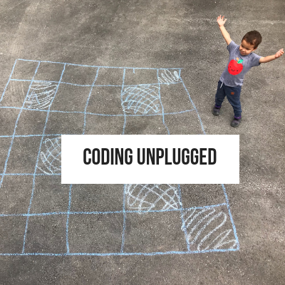

You can get started coding with your kids today! It’s easy, and all you need are items you likely already have around your house. To first start learning the basics of coding, you don’t even need a computer! One of our most popular unplugged coding activities involves learning to code with a deck of cards! You can find out how to learn to code with a deck of cards [here](https://teachyourkidscode.com/coding-unplugged-with-a-deck-of-cards/), or you can find our whole list of unplugged coding activities [here.](https://teachyourkidscode.com/coding-unplugged/)

### There’s an App for That!

If you’re like me, you struggle with appropriate screen time for your kids. I know that I got to the point where one more YouTube video of kids opening and reviewing toys was going to send me over the edge. We try to make our screen time as educational as possible. I even taught my son to play pianousing [this app!](https://itunes.apple.com/ca/app/piano-maestro-by-joytunes/id604699751?mt=8)

There are lots of amazing coding apps that can get your kids learning to code without even realizing it. Even popular games like Minecraft have an [education edition](https://itunes.apple.com/us/app/minecraft-education-edition/id1196524622?mt=8) that helps kids to learn to code. Ourfavourite coding app is this[one.](https://itunes.apple.com/us/app/code-karts-pre-coding-logic/id1222704761?mt=8) We have a whole list of the best coding apps for kids[here](https://teachyourkidscode.com/best-coding-apps-for-kids/).

### Start with an Hour of Code

One of the easiest ways to get a taste of programming basics for kids is with the fun and FREE hour of code activities available online. These activities are designed to take only an hour and can give kids and parents a chance to understand the importance of learning to code. We have an entire list of our favorite hour of code activities [here.](https://teachyourkidscode.com/free-coding-activities-for-hour-of-code-week/)

## But why is it important to learn how to code?

Why should kids learn coding? There are so many reasons to learn coding, it was hard to pick just 8 benefits of learning to code. From problem-solving skills, job opportunities, crtical thinking andcreativiy, there are so many reasons to learn programming. Let’s review why kids should learn to code.

## Here are 8 reasons why coding is important to learn for kids:

### Programming helps children learn to problem solve

Understanding computers and learning the basics of coding helps children to develop an appreciation of how things work. It also teaches them how software engineers use math in order to solve problems in a logical and creative way. This is an important reason that coding should be taught in schools, so children learn these skills while they are young.

The ability to solve problems is a trait that is useful in life in general. We all want our children to become excellent problem solvers so that they can overcome any adversity they face. Learning to code gives children the chance to learn this type of skill while they are young and it can help them along the way in life. This is one of the big reasons coding is important to learn.

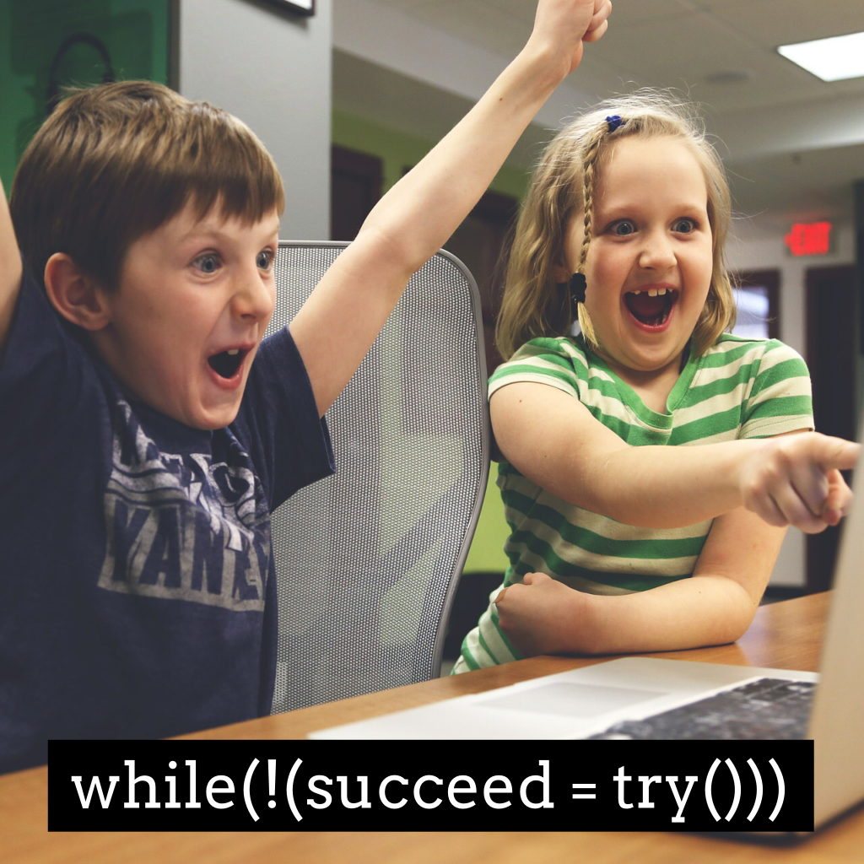

## Computer programming gives kids a challenge and helps them develop flexibility

When children learn to code, they develop the ability to bounce back after failure. They learn that failure isn’t necessarily a bad thing, and in fact, it can often be something positive because it serves as a learning opportunity. This is one of the most important reasons why kids should code, as they will learn quickly that ‘debugging’ your code is half the fun.

When you fail and try again you can learn from your mistakes. Coding gives children the ability to try and try again until they succeed and produce the result they are looking for.

## Coding teaches children how to think

“ A computer is a bicycle for your mind” – [Steve Jobs](https://en.wikipedia.org/wiki/Steve_Jobs)

[Learning to code](https://medium.com/@coderacademy/it-s-never-too-early-why-all-kids-should-learn-to-code-now-2a8b0a8bd2e7) teaches children how to think. Computer programming isn’t just about teaching how to type lines of code. It is more about teaching children how to think differently. Being able to code effectively, a programmer needs to use logical thinking. They need to be able to see a large problem and break it down into smaller pieces in order to solve it in an effective manner. This is called decomposition and is one of the key features of [computational thinking.](https://teachyourkidscode.com/what-is-computational-thinking/)

Children learning code will need to take a vague idea and use their creativity to turn it something effective. If the first solution doesn’t work, they try another one. If that one doesn’t work, they try again until the problem is solved. Coding helps to develop this way of thinking and these types of thinking skills are highly sought after.

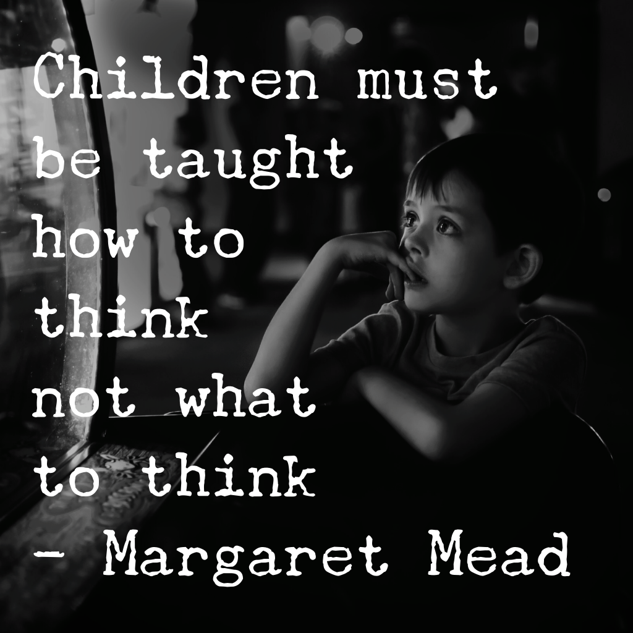

## A child expands their creativity when they learn how to code

Coding is important to learn because computer programming teaches children to experiment and gives them the confidence to be creative. They will have the chance to design something that is entirely their own. Children thrive off of the feedback they get from creating something they love. Just like learning a language, or to play a musical instrument, children need motivation. Usually seeing results along the way is enough to cultivate this, and this is what happens when children learn to code.

Because coding is easy to pick up, for children especially, confidence comes easily. When children learn how to code it gives them the opportunity to be confident and create something in a fun and exciting way.

Why is learning to code so important? For us, creativity tops the list! We love the creative games and activities our kids can create with coding. Coding doesn’t have to be boring, in fact, coding can be fun! We show you how to make coding fun for your kids in [this post.](https://teachyourkidscode.com/how-to-make-coding-fun/)

## Computer programming is the future

When you look at how the world is developing, coding is an extremely useful skill to possess. There are an increasing number of businesses who rely on computer code, not just those in the technology sector.

A child who [learns how to code](https://code.org/) will have the advantage in life with more employment opportunities available to them in the future, no matter which industry they decide to enter whether it be in the technology sector, finance, retail, health or other. This is an important reason why coding should be taught in schools.

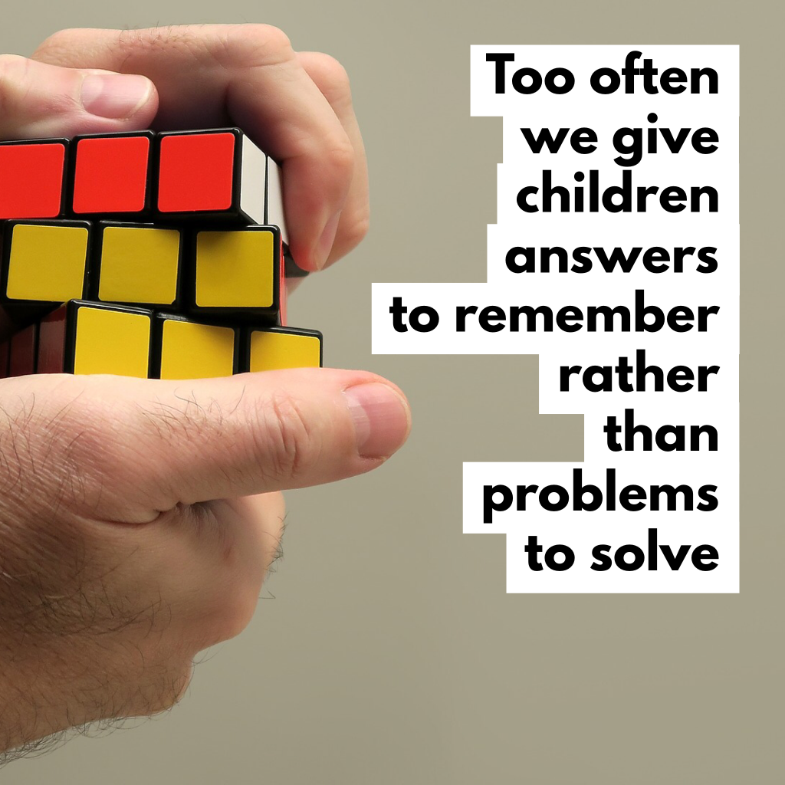

## There is a lack of skills in the software industry

Experienced computer programmers are in demand and with the advancement of technology, there are increasing career opportunities arising every day. Employees who can code are the future and are highly sought after in any industry.

Because qualified computer programmers are hard to come by, their salaries can be at a high level. If children learn to code at a young age, their experience starts young and they are more likely to grow up with an interest in the software industry, therefore contributing to our future.

## Coding helps children learn how to have fun with math

Coding is the language of maths. Imagine coding being taught in every school? Learning to program involves many skills including organizing and analyzing data. Children can grow their math skills while coding, without even realizing it. Using their logic and calculation skills while creating something of their own can make maths more engaging and fun. Another big reason coding should be taught in schools.



## Coding is learning while having fun

If you want to give your child something enjoyable to do which will also be educational and help them to learn, learning to code is the perfect gift. You can read about the reasons why coding is important, but one of the main ones is to give them a challenge while having fun!  
Children will learn various skills and with practice, gain some important skills that can help them through all ways of life, and if they can do all of this while having fun, why not?

## When should my kid learn to code?

In our opinion, teaching kids code is something that can be done as early as preschool. In fact, we have an entire post dedicated to ideas for getting preschoolers started with coding. You can read this[here.](https://teachyourkidscode.com/coding-for-preschoolers/)

As early as age 5, kids can learn the basic concepts of coding. Here are [5 coding concepts that 5 yearold can understand.](https://teachyourkidscode.com/coding-for-kindergarten-5-basic-coding-concepts-5-year-olds-can-understand/)

Even kids who can’t read can learn to code with block based coding. Check out [these coding apps](https://teachyourkidscode.com/best-coding-apps-for-kids/) that can help kids as your as 4 or 5 learn to code.

## Why is coding important to learn?

We have gone through some great reasons why coding is important to learn for not only children but anyone. If you have a child, giving them the opportunity to learn about technology and the way computers work will surely give them an advantage in life. Learning to code while they are young will set them up for a successful future.

## Pin for later!

# 9 reasons your child should learn to code (and one word of caution)

[**By: Ryan**](https://www.idtech.com/blog/author/ryan-barone) | Dec 12, 2017 9:05 AM

 Share

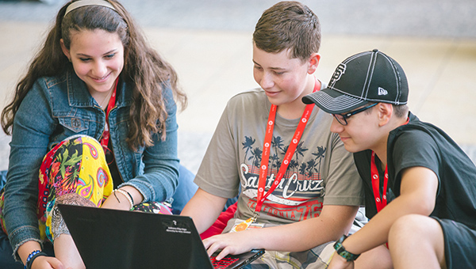

Over the last few years, you might have asked yourself at least once, “What’s with all the hype about coding?

I hear you!

But first, let me say it’s not just hype.

For now, let’s look at why students should code.

## Why Kids Should Learn to Code

Years ago when all of this kids and code chatter started, you could have characterized it has hype because the whole idea was new and novel to the education system. And, while this “learn to code” popularity spike wasn’t unfounded by any means, time was really the only thing that could tell us if it all was going to be a big fat flash in the pan.

Well, here we are.

Time has passed, yet we are still seeing [STEM education stats](https://www.idtech.com/blog/stem-education-statistics) like by 2018, 2.4 million STEM jobs will go unfilled. And others like 71% of all new jobs in STEM are in computing, [but only 8% of STEM graduates are in Computer Science](https://code.org/promote).

We’ve officially moved beyond simply saying “coding is cool, so go do it,” end of story. Instead, we are now saying, “coding is in fact cool, so go do it, but you should also go do it because you’ll be rewarded as a result.”

In other words, there are jobs, lots of them—and jobs that pay very well.

What makes this even better is that it’s not just the jobs or the coolness, either (this would be a much shorter blog post if that were the case). But also the creativity, problem solving, collaboration, communication, and other skills ripe for improvement as byproducts of kids learning to code.

So, let’s go!

1. Programmers are in high demand
2. Learning to code leads to a competitive advantage
3. Programming knowledge helps kids better understand the world around them
4. Coding is fun and satisfying
5. Coding improves creativity
6. Coding improves problem solving
7. Coding instills persistence
8. Coding improves collaboration
9. Coding improves communication

### 1. Programmers are in high demand.

As mentioned, according to Code.org, 71% of all new STEM jobs are in computing, yet only 8% of STEM graduates are in Computer Science. That’s a SERIOUS shortage of CS majors.

Learning to code will increase your child’s odds of securing a lucrative STEM career, especially in a world where computing jobs are growing at over twice the national average.

Coding has quickly become a vital skill, and Code.org also points out that CS majors can earn 40% more than the college average.

### 2. Coding provides a competitive advantage when applying to colleges, internships, and jobs.

If you possess a hot skill that many of your peers lack–such as the ability to code–you instantly appear more desirable in the eyes of potential college admissions officers and employers. Plain and simple.

### 3. With programming knowledge, students better understand the world around them.

Most of us don’t know the first thing about what makes our smartphones, laptops, social media networks, and video games run. Basic programming knowledge can change the way we interact with the technologies we use (and take for granted) daily, and can open our eyes to the infinite possibilities of coding.

### 4. Programming is fun and satisfying.

While programming is logic-based, it’s also an extremely creative activity. If you know how to code, you can develop the aforementioned apps, video games, websites, and more!

For many developers, part of the appeal of coding is the challenge and reward of seeing their code come to life after a good debugging session. Don’t be fooled, however–with the right instruction, getting started with programming can be easy and fun.

### 5. Coding improves creativity.

When you learn a language, you use it to express yourself. The same is true with code. Coding empowers kids to not only consume digital media and technology, but to create it. Instead of simply playing a video game or using an app, they can imagine [making their own video game](https://www.idtech.com/paths/game-development), or envision what their own website, or app might look like—and they’ll have the outlet for expression.

### 6. Coding improves problem solving.

When kids code, they take complex problems and break them down into smaller parts.

Kids learn what it’s like to approach a problem the way a software engineer does, with logical, computational thinking.

As Dan Crow, CTO of SongKick explains, “Computational thinking teaches you how to tackle large problems by breaking them down into a sequence of smaller, more manageable problems.”

This logical thinking is a powerful tool in school, work, and life.

### 7. Coding improves persistence.

Learning to code, like any new discipline, is a challenge. Thus, tackling complex problems—and making mistakes along the way—can be very frustrating.

Coding teaches the valuable skill of persistence in the face of such challenges. Learning how to problem solve and look for solutions through research and collaboration builds this highly desirable skill.

### 8. Coding improves collaboration.

Anyone can learn how to code—kids can learn alongside others of every race, gender, or background. Kids meet and learn how to collaborate with all kinds of peers, all joined by a common interest in technology.

Classrooms and other in-person environments, like iD Tech, bring kids together for face-to-face collaboration. Kids learning online can also grow, asking each other questions, and working to solve problems and create things together.

Many games, like Minecraft, [also offer a bevy of educational benefits](https://www.idtech.com/blog/educational-benefits-minecraft) because they too involve coding, collaboration, and participation—with peers all over the world.

### 9. Coding improves communication.

Communication is an absolutely essential skill throughout school, work, and life. People who can clearly communicate complex ideas in simple terms tend to be successful in different industries and walks of life.

When kids learn how to code, they learn how to communicate with the most simple-minded audience imaginable: computers. As mentioned, coding teaches kids how to break down complex ideas and arrange them in a way that computers can understand.

## But with all of that, proceed with caution…

OK, I'm not going to turn around now and say you shouldn't learn to code, obviously, but more of...

Why just code?

It’s natural for such a simple question and the following related questions to crop up as you break down whether or not coding is right for your child:

What if my child doesn’t want to learn to code, specifically? Does that make them a failure?

Will they not have the chance to secure a cool internship down the road? A worthwhile job?

What if they want to learn to just “tech” instead? Is that a viable option?

What if they want to learn X? Or Y? Or Z? Will those things count in the future?

Likewise, if they only learned to code, and nothing else, would that take them to the top?

So, let me wrap up by saying me or whomever else urging you to “learn to code” is probably not doing so with the intent of the statement to be so exclusive.

I mean, you would never be encouraged to read, but not write. Or to learn your multiplication tables while throwing division out the window. Facebook was created by a programmer, but what would it be without design?

So, by all means, if you have a kid with a coding interest, then yes, help them to LEARN. TO. CODE. If they don’t have an interest, still consider it, though. It’s that important, and you’ll be glad you at least gave it a chance.

But in the process, don’t forget about the other things. Help them learn to “tech,” and explore [game development possibilities](https://www.idtech.com/paths/game-development), [3D printing](https://www.idtech.com/courses/3d-modeling-and-printing), or [video production](https://www.idtech.com/courses/youtube-gamecasting-and-video-production) if that's what better suits them. Immerse in [photography](https://www.idtech.com/paths/design) if that's truly what they want to do as a hobby or even a future career.

Have them get skilled in marketing, negotiation, promotion, and more… or learn how to become a leader. There is a list of learning opportunities, and that list goes on and on. Coding can take you far, but you must also possess the complementary skills to make your creations thrive.

One of the most amazing things you’ll ever hear is that [Steve Jobs didn’t code for Apple](http://www.businessinsider.com/steve-jobs-never-wrote-computer-code-for-apple-2013-8). Ever.

Can you believe that? If I asked you whether or not Steve Jobs was successful, you’d turn around and ask me if the sky was blue or if grass was green.

Jobs was one of the most successful people to roam the earth… not because he was a supreme coder, but because he knew enough to communicate a vision, and was wildly skilled elsewhere.

### Next Steps

In the end, kids and teens who want to capitalize on the abundance of computer science jobs in tomorrow’s landscape should be taking [programming courses](https://www.idtech.com/paths/coding) today.

iD Tech students arrive in the summer eager to learn—not only because of their interests in technology,  but because many of them still aren’t receiving valuable instruction in subjects like coding with their everyday schooling. They leave camp with new skills, deeper knowledge, and the confidence to go out and do something impactful with what they’ve learned. We’ve seen this happen summer after summer.

And now, [kids can learn coding online](https://www.idtech.com/online) with our Online Private Lessons!

Best of luck! See you next summer, online, or both!